CampusPulse: Geo-Location Based Attendance System Using Wi-Fi BSSID Validation and Multi-Factor Authentication

Sumith Kumar V | Ravi Ranjan | Hrishikesh Vivekanand Ghodke
20221COM0192 | 20221COM0185 | 20221COM0152
Computer Engineering | Computer Engineering | Computer Engineering
Presidency University | Presidency University | Presidency University
Bengaluru, India | Bengaluru, India | Bengaluru, India
kumarvsumith@gmail.com | raviranjan8199@gmail.com | hrishikeshvivekanandghodke@gmail.com

Abstract—Educational institutions have depended on manual or biometric hardware as traditional attendance systems. Such systems are labor-intensive, expensive, and subject to the risk of proxy attendance. Mobile solutions using either GPS or app- based verification that look to automate attendance are not very effective for indoor accuracy and fall victim to location spoofing attacks. Literature shows that Wi-Fi infrastructure (more specifically, BSSID identification of devices connected to Wi-Fi) will be an effective way to detect indoor attendance. Additionally, research into GPS security has identified that GPS is vulnerable to spoofing and to creation of a false/mock location. Further, authentication research has found that it is not sufficient for an authentication method to be single-factor, and that two-factor/multi-factor authentication is recommended for a more secure successful authentication system through the use of both a biometric and knowledge-based factors. To overcome the above-referenced issues, this research proposes an attendance system that provides a secure geo-locational identification of each user by utilizing BSSID validation, an Operating System (OS) level detection of mock GPS location, and a device level multi-factor authentication using Android biometrics with a personal identification number (PIN) backup. The multi-tier architecture of the proposed attendance system consists of an Android mobile application, a web-based administrative interface, and a centralized back end with a PostgreSQL database. Therefore, this proposed attendance system improves upon the ability to detect proxy attendance and mitigate the risk of spoofing location while maintaining the anonymity and privacy of each user by not storing biometric data.
Index Terms—Geo-location, Attendance System, Wi-Fi BSSID, Spoofing Detection, Multi-Factor Authentication, Android Security

- Introduction
Management of attendance at educational establishments or other types of organizations is an important requirement due to its impact not just on individual students’ academic perfor- mance but also on institutional decision-making (e.g., tracking participation, making administrative decisions). Traditionally, attendance has been recorded using paper-based methods (e.g., sign-in sheets, manually completing attendance registers) that are inefficient because they take a long time to complete and
are subject to human error. Though RFID-based and biometric attendance systems help to automate the attendance process, their use requires installing and maintaining additional hardware infrastructure, which adds cost or complicates implementation [8],[9].
Smartphone-based attendance systems have gained popularity in recent years because they reduce manual effort associated with maintaining attendance records (recording, tracking). For example, GPS-based attendance systems allow a user to verify their presence at a location by being geographically close to it. However, GPS cannot be used to reliably verify attendance indoors because, in many cases, GPS signals are weak or blocked due to obstructions such as walls or buildings [5]. Additionally, as mobile operating systems can be manipulated with mock location settings, GPS only attendance systems are vulnerable to spoofing/fraudulent check-ins [1]. These limitations demonstrate that GPS-based systems alone cannot provide secure attendance verification for classrooms or workplaces.
Wi-Fi-based indoor positioning technologies can provide more reliable alternatives for verifying a user’s location indoors. Research conducted on using Wi-Fi fingerprinting demonstrates that use of access point data can produce reliable indoor localization without requiring any additional hardware [3],[7]. Research has also shown through anonymized Wi-Fi BSSID data that location and movement behaviour can be inferred from nearby Wi-Fi signals, thus demonstrating how useful Wi-Fi context can be used to determine if a person is physically present [2]. Since most universities already have a Wi-Fi network in place and nearly all students own a smartphone, attendance systems that are based on Wi-Fi can be rolled out
quickly and at a fraction of the cost of traditional systems.
To fill the gaps in the current attendance systems, this project proposes a multi-verification attendance system that utilizes multiple means to verify identity, location and to detect spoofing. This system will make use of Android biometric authentication for User Identity, Wi-Fi BSSID values for validation of Indoor Location and detection of

mock locations for reducing fraudulent claims of attendance. This multi-verification approach aims to provide a more secure and reliable attendance system compared to the current manual attendance systems, RFID attendance systems, QR-code attendance systems or solely GPS-based attendance systems [4], [5], [8], [9]. The proposed system will be implemented via an Android Mobile Application, Centralized Backend Database and Web Based Administrative Dashboard.
- Related Work
Numerous automated attendance management systems have been developed in recent years to help schools increase the speed and accuracy of student attendance tracking systems. The initial versions of these systems used radio-frequency identification (RFID) for collecting attendance information. In this approach, students carry a personal identification badge, which is read by an RFID reader when they enter a classroom or building. While RFID has increased the speed that attendance data can be collected, it also makes it easier for students to participate in proxy attendance, as one student could use another student’s badge for presence tracking [8].
In contrast with token-based attendance systems, biometric- based attendance systems provide a stronger level of identity verification (through fingerprints, photographic images of the individual’s face, etc.) than do token methods. These systems lower the risk of impersonation because they depend on unique physical attributes that do not easily lend themselves to transfer or sharing. The downside of using biometric systems, however, is that they often require specialized hardware to be installed in the classroom, which increases both the initial and ongoing costs of implementing the system in an educational institution [9].
The most current attendance systems are increasingly using smartphones to mark attendance using GPS features. This has enabled users to mark attendance using their smartphones without needing specific attendance hardware, unlike the previous systems that required students to use specialized attendance hardware [5]. One of the challenges with using GPS-based attendance systems is that GPS accuracy in indoor settings is often low because large structures can weaken or block GPS signals coming from the satellite. Additionally, GPS-only attendance systems are vulnerable to manipulation by students using apps such as mock location apps and GPS spoofing apps.
Researchers have also looked at using Wi-Fi as a way to track attendance (Wi-Fi based localization). Two methods for GPS like attendance tracking using Wi-Fi are through Wi-Fi Fingerprinting and BSSID (Access Point Identifier) based validation. Wi-Fi Fingerprinting uses a pattern of signals received from the surrounding access points within the area to find where a person is located, which is well suited for indoor locations and subject to less interference than GPS [3, 7]. Similarly, BSSID based methods look at access point identifiers to determine if users are present in a certain area in relation to their current location, such as in a classroom or office space [2]. These types of systems require that organizations
have a preexisting Wi-Fi infrastructure and can operate without additional expensive hardware that other GPS-based attendance systems require.
Systems still vulnerable to impersonation and proxy at- tendance because they rely completely upon either user- names/passwords for authentication or alternatively on location information. In order to increase confidence in those systems, previous studies have concluded that we should be combining location validation with robust identity assurance methods such as biological recognition systems and device level security measures [13] , [10] . Detecting spoofing is another method of ensuring that location information is valid; this particularly applies to mobile devices which may be configured to give false location information [5] . Thus, a secure attendance solution should include Wi-Fi BSSID validation, spoof detection and biological identification in order to increase both the system’s reliability and its resistance to fraudulent activity.
- System Architecture
An effective security multi-tier client/server application for a proposed geo-location attendance system is composed of three main components:
- The Android Mobile Application;
- The Backend Server;
- A Web-based Administrative Dashboard
The Android Mobile App will authenticate users using biometrics with a fallback to a PIN number, verify their location using Wi-Fi BSSID, verify the location was correct, and if the user has enabled mock location settings, reject their attempt to submit their attendance.
The Backend Server will receive attendance requests through secure REST APIs, verify that the BSSID (Wi-Fi access point) has been approved by using geo-fencing, issue authenticated tokens, enforce access control by role, store all records in a PostgreSQL database, and maintain audit logs.
The Web-based Administrative Dashboard will allow Administrators & Teachers to administer users and roles, asso- ciate/classroom mappings to their respective Wi-Fi networks, view attendance records, and generate reports.
Using a multi-tier architecture ensures that the identity, location & integrity checks for recording attendance have all been successfully completed.
- System Workflow
The above sequence depicts the workflow of the proposed application system: Fig. 2.
- The user first accesses the Android app that has been developed.
- After logging in, the user will go through biometric authentication (or enter a PIN/password if necessary).
- Next, the current location of the device will be obtained, and a scan of nearby Wi-Fi BSSID values will be conducted.
- In addition, the system will verify the status of mock location services on the Android device.

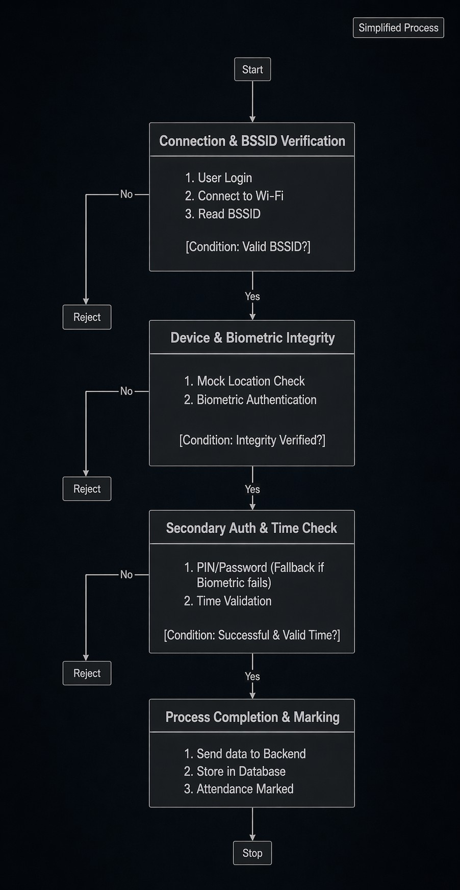

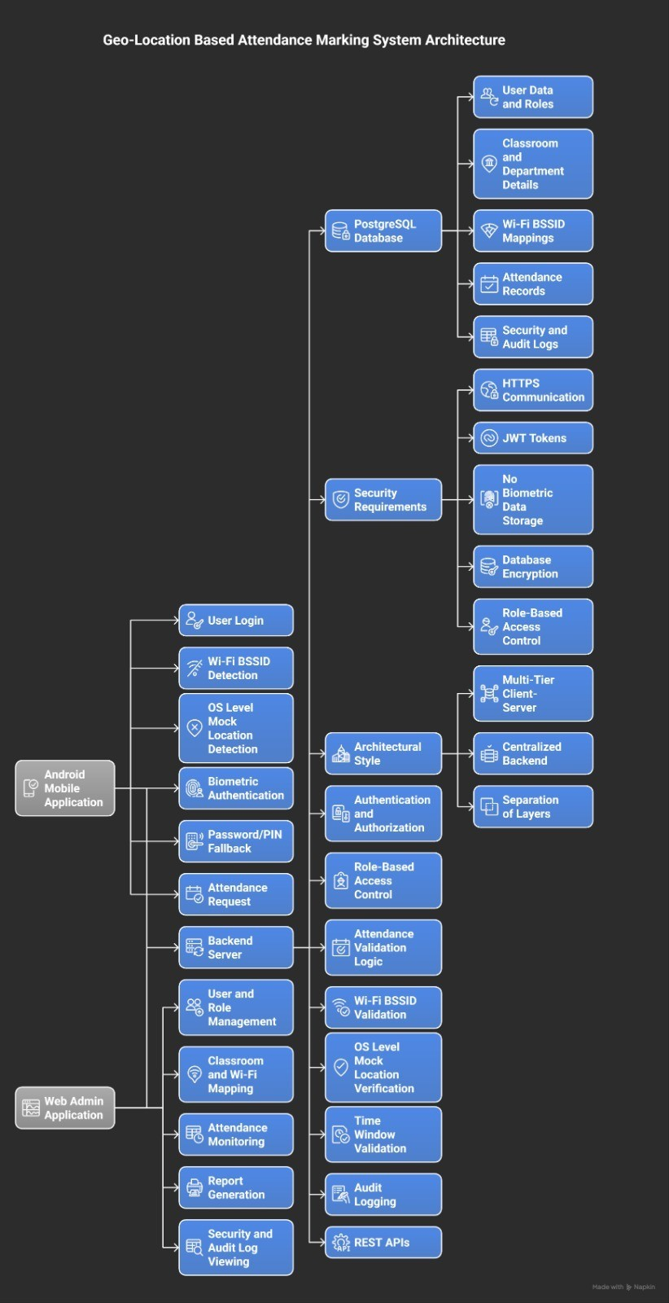
Fig. 1. Geo-Location Based Attendance Marking System Architecture

- Once this information is obtained, attendance for the current date will be sent via an encrypted API to the backend-server.
- After sending the attendance data to the backend-server, the server will validate the user’s role, check for the time window, confirm the mapping of the BSSID values, and confirm that the location is accurate.
- If the data are valid, it will be recorded in the PostgreSQL database as attendance.
- Audit logs will also be created for tracking and auditing purposes..
Fig. 2. Flowchart of Geo-Location Based Attendance System

- Algorithm for Attendance Verification

Algorithm 1 Secure Attendance Verification

1: User opens attendance app
2: Perform biometric authentication
3: Get GPS location
4: Scan nearby Wi-Fi BSSID
5: Check mock location flag
6: if mock location detected then
7: Reject attendance
8: end if
9: if BSSID matches authorized network then
10: Mark attendance
11: else
12: Reject attendance
13: end if
- Implementation
The newly created system for recording attendance using geo-location technology is made up of three parts: an Android app running on the mobile phone, a back-end (server-side) application, and an administrative dashboard that can be accessed through a web browser.

Android Mobile Application
The Android mobile application was built using Kotlin and utilizes the Android SDK to create the application. The application converts either a fingerprint or facial authentication into an Android Biometric API where PIN is available as a fallback mechanism (for times when biometric information is not available). Device location is captured from the device using the Android Location APIs and by scanning Wi-Fi access points in the vicinity in order to acquire the BSSID (Basic Service Set Identifier) of the access points that are available. Once the location and the set of BSSID(s) are collected, the mobile application checks for operating system level mock location providers in order to determine if an individual is attempting to spoof their location prior to submitting an attendance request to the back-end server.

Backend Server
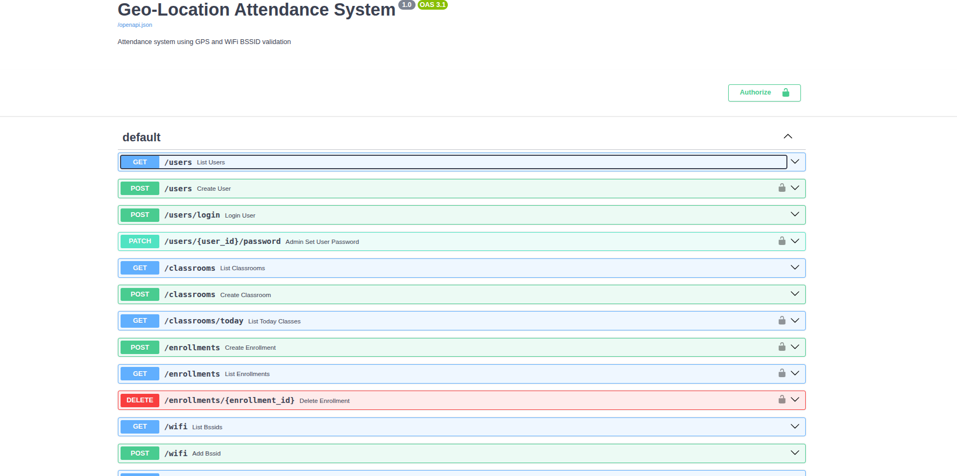

Fig. 3. Execution of Backend or Docs page of Campus Pulse
The back-end server uses a RESTful API to process the attendance requests submitted from the mobile application
, verify BSSID(s) based on authorization obtained from the classroom networks, and to perform additional criteria that must be satisfied prior to processing an attendance request, such as validating the attendance request is within the normal operating attendance time period and that the attendance request is from a valid location. The back-end server will produce an authentication token for the user who is submitting their attendance request. The back-end server also will record the transaction information in a system audit log file, which can be used for historical data review.

Database System
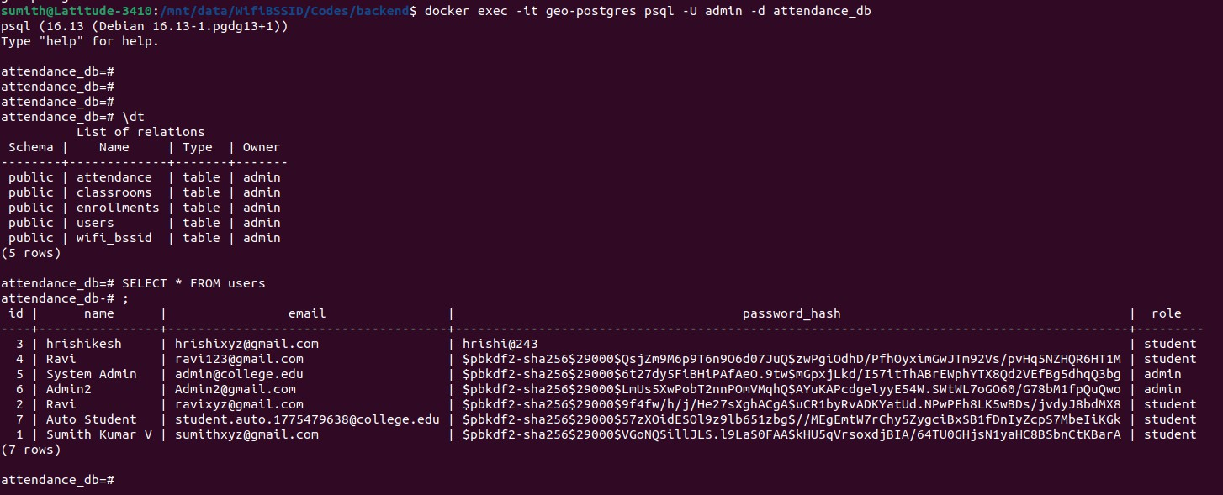

Fig. 4. CLI execution of PostGres Terminal Image of Data
The entire attendance system data (user profile, classroom information, BSSID mappings, attendance log and security
TABLE I
System Evaluation

Test Case | Result | Accuracy
GPS-only attendance system | Vulnerable to location spoofing | 65%
Wi-Fi BSSID verification | Reliable indoor detection | 92%
Proposed secure system | Biometric + Wi-Fi validation successful | 96%

audit log) data will be stored in a PostgreSQL relational database.

Web Administration Dashboard
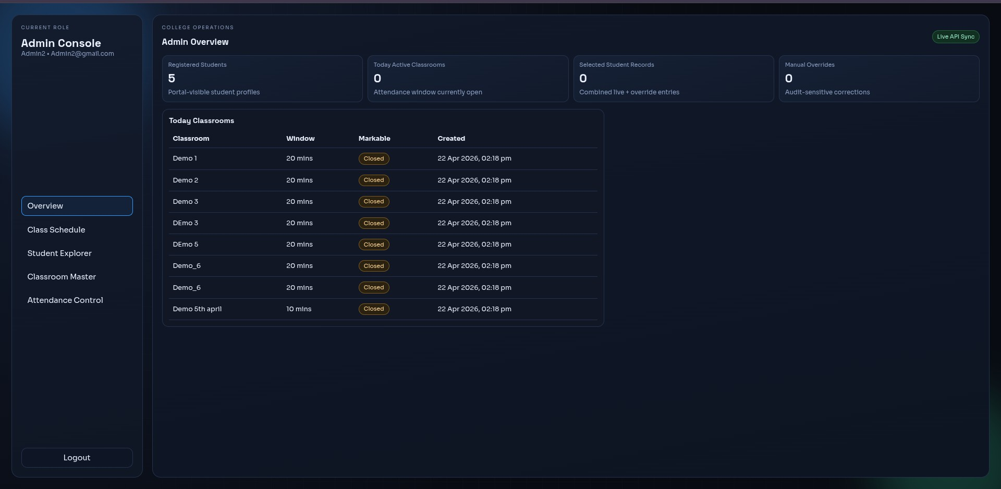

Fig. 5. Admin Console Ui
Using HTML, CSS, and Javascript, we have created a web- based dashboard that allows faculty and administrators to manage users, configure classroom WiFi mappings, monitor attendance, and generate attendance reports.
Secure communications between the Android app and the backend server are established through HTTPS, to enable the transmission of data in a confidential and secure manner.
- Experimental Evaluation
The proposed system was evaluated in a classroom on the university’s campus using authorized Wi-Fi networks. A number of test cases were executed to evaluate how well the location verification and spoofing detection mechanisms functioned.
During the evaluation, students attempted to mark their attendance using various methods: as they normally would; by way of GPS spoofing; and using Wi-Fi validation. Biometric authentication was used to verify the identity of the user and determine the location of the user by comparing the BSSID values of Wi-Fi networks in close proximity to authorized classroom networks.
The results demonstrate that using Wi-Fi BSSID validation in conjunction with biometrics and mock location detection drastically improves accuracy in verifying attendance. The proposed method of using Wi-Fi, biometrics, and mock location to verify attendance has much higher resistance to location spoofing and proxy attendance than systems that only utilize GPS, and still provide reliable detection of attendance indoors.
- Security Analysis
The proposed attendance verification solution consists of several security methods to combat the threats associated with

mobile-based attendance systems.

Proxy Attendance
Proxy attendance occurs when one user marks attendance for another user. The proposed method combats this risk with multi-factor authentication at the device level. To verify the identity of the user before marking attendance, biometrics such as fingerprint or facial recognition are used. A fallback mechanism allows the user to continue using their PIN while maintaining user security.

GPS Spoofing
Many mobile devices running the Android operating system support the operation of mock location applications that can be used to manipulate GPS coordinates. The attendance verification solution will detect attempts to use a mock location provider by determining whether or not the operating system has enabled the use of a mock location provider. If a mock location provider is detected, the attendance verification request will be denied, thus preventing the user from being able to spoof their location.

Indoor Location Verification
GPS signals are not very reliable indoors. To make sure this doesn’t happen, the system checks for any Wi-Fi access points nearby by scanning for their Basic Service Set Identifier (BSSID). If the Wi-Fi BSSID that it finds matches the Wi-Fi network used in that classroom, then it will mark that device as being in the right location and being present in that classroom.

Data Protection
The system does not keep any biometric information on the server; instead, it uses the secure hardware module in the Android operating system to perform biometric authentication locally. Attendance records in the PostgreSQL database, along with any other user data stored there, are secured by implementing role-based access control and audit logging.
- Limitations
While the proposed geo-location attendance system presents greater levels of security and reliability than previous methods (such as manual attendance-taking, RFID-only, and GPS-only), there are still a number of limitations.
- Reliance upon the campus’s Wi-Fi infrastructure: The system is dependent on the availability of consistent and stable Wi-Fi access points by the institution. If the Wi- Fi coverage in an area is weak, the access points (APs) experience some downtime, or network reconfiguration occurs frequently, then BSSID-based verification will degrade in accuracy below acceptable limits.
- BSSID maintenance burden: Over time, access points may be replaced, reconfigured, or renamed, creating a requirement for the institution’s approved repository of BSSIDs to be updated by administrators regularly. Therefore, additional operational effort will be required to ensure the accurate operation of this system.
- Overlap from indoor proximity to boundary ambiguity: In some dense building construction, adjacent classrooms may overlap to provide multiple viable sources of Wi- Fi signals to determine a classroom’s location. As a
result, determining the occupancy of a particular room will become more difficult, unless another source of fingerprinting or signal strength models is utilized.
- Device fragmentation and variability in Operating Systems: Biometric sensors available on Android devices are heterogeneous in their form-factor, behaviour regarding permission requests, and the way they perform Wi-Fi scans. As a result of the differences; variability in performance and the user experience can occur.
- Limitation of platform availability for the implemen- tation of this system: Currently, the implementation is available only to Android-based devices. If the system is to be made available to other platforms, then additional engineering and validation will be required to ensure similar levels of security will be provided.
- Conclusion
In this paper, we describe a secure, geo-located Attendance System which uses a combination of Wi-Fi BSSID validation, operating-system-level mock location detection, and a multi- factor device-level authentication.
Results from testing the proposed system in the classroom environment show the system provides improved accuracy in verifying attendance as well reduces the opportunity for proxy attendance and location spoofing when compared to traditional GPS-based attendance systems.
The system provides a cost-efficient and scalable solution for indoor location validation, utilizing both secured authentication methods and indoor validation. No additional physical devices are required beyond those already in place.
Future research could include applying BLE beacons, positioning technology, and/or machine learning-based methods to enhance the accuracy of indoor positioning within complex settings.
References
- M. Foruhandeh, A. Z. Mohammed, G. Kildow, P. Berges, and R. M. K. Gerdes, “Spotr: Gps spoofing detection via device fingerprinting,” in Proceedings of the 13th ACM Conference on Security and Privacy in Wireless and Mobile Networks (WiSec ’20), 2020.
- M. N. Sakib, J. B. Halim, and C.-T. Huang, “Determining location and movement pattern using anonymized wifi access point bssid,” in 2014 7th International Conference on Security Technology, 2014.
- S. He and S.-H. G. Chan, “Wi-fi fingerprint-based indoor positioning: Recent advances and comparisons,” IEEE Communications Surveys & Tutorials, vol. 18, no. 1, pp. 466–490, 2016.
- O. O. Ojuawo and A. J. Alawode, “A mobile application for an improved student attendance monitoring system,” International Journal of Latest Technology in Engineering, Management & Applied Science, vol. 11, no. 11, 2022.
- A. Jadhav, A. Angadi, and S. S. Padmannavar, “Gps based attendance system,” International Journal of Scientific Research and Engineering Development, vol. 6, no. 4, 2023.
- GNSS-SDR Project, “Gnss-sdr: An open source global navigation satellite systems software-defined receiver,” 2020, used for GPS signal processing reference.
- V. Authors, “Survey on wi-fi fingerprinting techniques for indoor localization,” IEEE Communications Surveys, 2015, general reference for Wi-Fi localization.
- ——, “Rfid-based attendance management systems: A survey,” Interna- tional Journal of Engineering Research, 2015.
- ——, “Biometric-based attendance systems using fingerprint recognition,”
IEEE Transactions on Pattern Analysis and Machine Intelligence, 2002.

